I COMPANY DESCRIPTION
Spengler is world class and five star hotels with a simple in the Davos City in Switzerland. The hotel is open to open-minded travellers, weekend adventures and smart business people. Spengler Hotel Davos is a hotel of choice when a client is looking for a special place for special occasions like conferences, meetings; delicious or tasty meals at the hotel; drinks in the bar or lounge; a hotel room or an apartment. Spengler Hotel Davos is very unique with interior designs with various types of rooms, suites, and banquet halls of different sizes including the “Grand Ballroom” which can carry more than 2000 guests for seminars, workshops, meetings, conferences, and other celebrations like weddings. With restaurant and accommodation facilities, convenient hotel and versatile space, Spengler provides the clients with unique and particular special restaurant and hotel services and experiences. Spengler Davos Hotel is a world class international hotel that is one of the leading groups in the hospitality and tourism industry not only in Switzerland or Europe but internationally. In Switzerland, Spengler Hotel Davos is ranked the best five-star hotel in the Tourist and Hospitality Industry. Presently, the hotel has various hotels and resorts internationally. The hotel offers welcoming and restorative episodes and experiences in their various numbers of hotels in the whole world. Spengler Davos hotel provides free internet services which operate at high speed, comfortable beds, and various restaurants and hotels choices that match the needs of their clients. The hotel strives to make their clients to feel truly refreshed and restored, and get a home away from home especially when in a journey.
Spengler Hotel Davos provides commercial center, cultural attractions centers and easy access to the airport to their guests. With spacious and stylish rooms, the hotel offers both business as well as leisure of the clients who are in a journey, whether on short-period or long-period. Spengler Hotel Davos offer services and comforts to their clients that meet the needs of the guests. The guests have a broad range of choices of drinks and food at the “Orchid Restaurant”, the R Café and the 24-hours room services. Moreover, the hotel provides highly rated facilities and services such as free access to the hotel gym and hotel beach club, spa, and indoor swimming pool.
II BUSINESSMISSION
The corporate mission of Spengler Hotel Davos in Switzerland is always to offer quality and fresh food truck in the Charlotte and quality services to their client at any time.Located in Switzerland, Spengler Hotel Davos commits itself to bringingfood truck in the Charlotte and quality services to the entire Europe and worldwide. To accomplish this mission, the present menu of the Spengler Hotel Davos is diversified to be in a position of achieving the demands of their guests.
III SITUATION ANALYSIS

IndustryAnalysis
In order to offer a completeness and comprehensiveness of matters that may have direct influence on the strategic position of the current business activities of the hotel, various analysis levels shall be offered starting with external factors (macro-environmental analysis) commonly known as PESTEL factors (Political, Economic Social, Technological and Legal factors ).
Political Factors
The decision taken by the Government of the Swiss to adopt the Free Trade Pact with the Republic of China on the 6th July 2013 led to enormous improvements in the accessibility to the Chinese and Swiss markets for the two nations.The Free Trade Agreement has positively impacted on the Swiss Tourist Industry that has resulted to around 33% of growth in the bookings of the hotels by the Chinese tourists visiting Switzerland.
Economic Factors
The Swiss National Bank decided to do away with the minimum exchange rate in January 2015 of 1.20Sf for one euro raising its value to about fourteen per cent. This made the prices of various services in Swiss to be affordable (Lichtenthaler2009). As a result, Swiss Franc become cheaper against other currencies and reports indicated that many tourists began to see Switzerland as a cheap holiday destination and therefore seeing a tremendous increase in the number of visitors in Swiss. The hotel industry has expanded as a result of more tourists visiting Switzerland.
Social Factors
The greatest social trends are represented by the new sharing economies which individuals are responsible to create. The old couples as well as the millennial generation or individual tourists or travellers are all searching for experience that is diverse that includes emotional edge as well as economic gain in sharing their stay according to a more personal travel-philosophy and intimate
Technological Factors
. Important platforms that are internet-based have become more prominent, and their use has greatly influenced the hotel industry in Switzerland. Among them, Airbnb emerged and increased the competition level within hotel industry in Swiss and therefore Five-Star Hotel such as Spengler Hotel Davos has opted to specialize on offering high quality services by applying the modern technology that has made the hotel to have competitive edge over their rival hotels.
Ecological Factors
Switzerland is considered a nation which mainly invests in her tourism sector in the winter period. The country is a snow-reliable with about 85% of the hotels making more returns during the season of winter. Nevertheless, as a result of global warming and greenhouse effect has negatively influenced the tourism sector with reports indicating a decrease of six per cent of the tourists in 2014/2015 winter season.
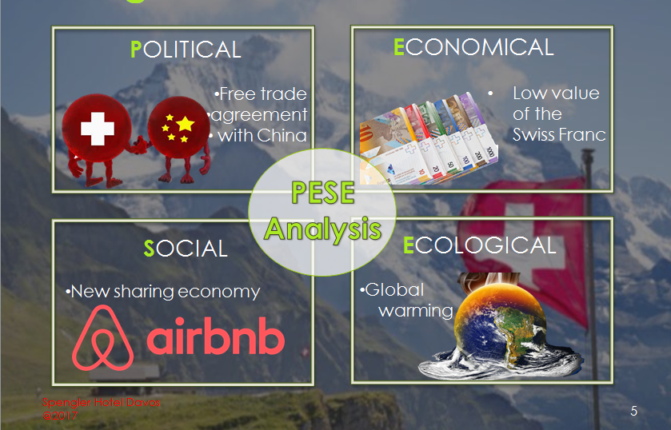

Porter’s Forces

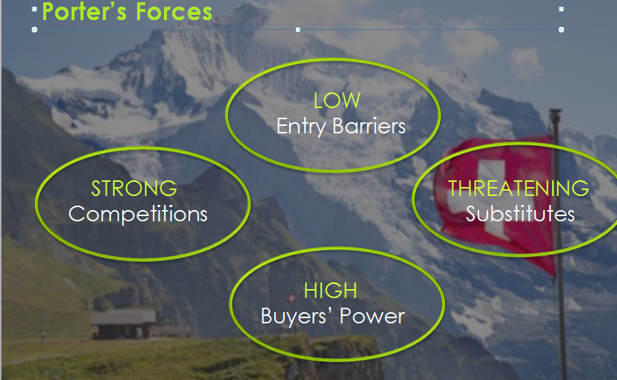

After analyzing the most essential components of the external environment have been outlined, it necessary to particularly focus on whether the hotel industry to which Spengler Hotel Davos operates can be considered as being attractive. This can be done through Porter Five Forces Analysis of 1979.
The first component which leads to the evaluation of the attractiveness is the entry barriers. The enormous expenses of financial funding, the needed legal requirements to build the hotel which match the dynamic and competitive hotel environment and the Swiss Franc fluctuations complicates the difficulty level to achieve the break-even point in the entry barriers of the Swiss hotel sector. In addition to the macro factors, the economies of scale that hotels such as Spengler Hotel Davos need also to be interpreted as a possible entry barriers as it could be possibly hard for new hotels to achieve greatness and the prosperity of well-established hotels.
Nevertheless, the hotel sector does not normally allow the successful and large hotels to depend on their established prosperity to succeed. In the dynamic business world characterized with new innovations and inventions, as well as new social trends for examples Airbnb trends already explained, even world class and five-star-hotels such as Spengler Hotel Davos needs to face the possible threats. These may be seen as substitute goods or services that specifically in the mountainous areas may be easily be as worth as the experience of the hotel. Individuals are for sure encouraged to save their cash particularly regarding long term holidays where it may be more reliable to rent a room on normal agencies of hotel or on the Airbnb.
The buyers bargaining power is raised by the increase of the substitute products. Such are intended as both the agencies that develop a contract between the current hotel and the clients and also the hotel’s immediate guests. The selections of the visitors are increasing and actually meeting the new codes of the accommodation and desperately meet the travel experiences. Another factor that must be considered by the Spengler Hotel Davos is the competitors of the hotel.
Spengler Hotel Davos is offering high quality services that provide it with competitive edge over its rival competitors. Not only are theSpengler Hotel Davos hotels spread throughoutSwitzeland, Europe and globally, theSpengler Hotel Davos have the best locations for the airport globally as compared to all the brands of the hotel internationally.

The Spengler Hotel Davos SWOT Analysis
Strengths
Customer Loyalty
With the wide variety of choices and selections in the Tourist and Hospitality Industry such as Hilton, IHG, Ramada and Premier Inn, The Spengler Hotel Davos has created good reputation for itself that has enabled the hotel to have loyal guests that believe and trust to the services offered by the hotel (Simon et al.2011). Rather than targetting all the gusets, the Spengler Hotel Davos only requires to target new guest in order to remain relevant as it grow and expand to acquire new markets.
Size Advantages
The advantages of the size lower the risks of theSpengler Hotel Davos. The larger the Spengler Hotel Davos expands, the more the hotel gains economies of scale to acquire resources to be in a positon to pursue the new global markets and competite favorably with the rival hotels.
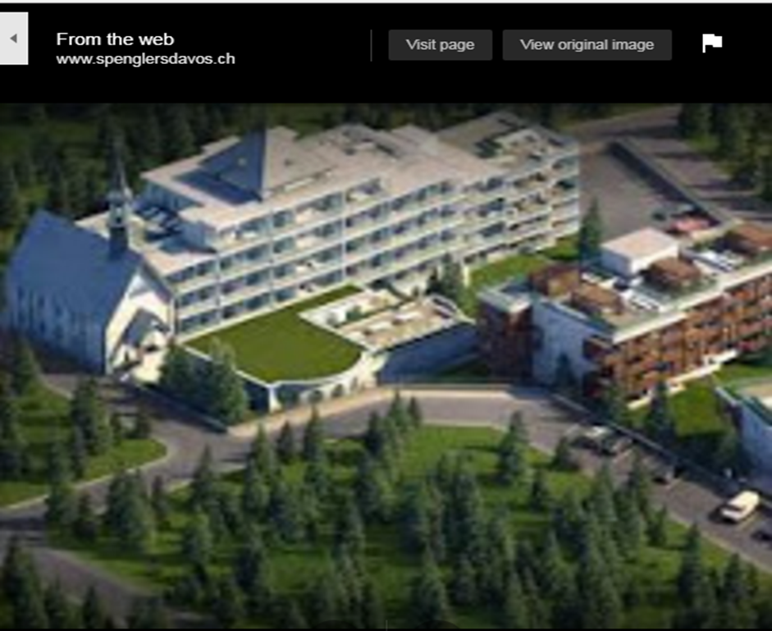
Brand Name
Spengler Hotel Davos has a good international reputation with a strong brand name that makes the hotel to be outstainding in the Tourist and Hospitality Industryin Switzerland, Europe and worldwide. This offers theSpengler Hotel Davos the ability to provide their services at high prices since the guests put additional value in the brand name.
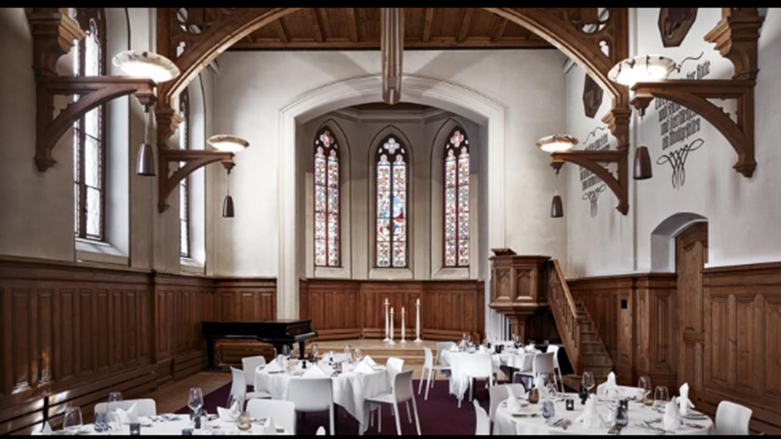
Strong Management
The stong management of Spengler Hotel Davos assists the hotel to attain its maximum productivity by reducing on its weaknesses and buillding on its strengths.
Technology
Advanced and modern technology enables the Spengler Hotel Davos to achieve the demands of the guests in better ways that their competitors cannot imitate.
Weaknesses
Cost Structure
Aweak structure of the cost imply that Spengler Hotel Davos costs of the operations are high as compared to their competitors.
Opportunities
New services
The new serveces assist Spengler Hotel Davos to meet the demands of the customers better than the competitiors. The new services can help the Ramada Hotel to diversify the base of their clients and guests.
New Internal Technology
Modern and advanced techonlgy enables theSpengler Hotel Davos to improve the needs and demands of the customers through improving their servicies and products. The modern technology also enables theSpengler Hotel Davos to build a competitve barrier against the competitors.
New Products
Development of a new service or product can assist the the Spengler Hotel Davos to grow their hotel and to divesify the base of their customers and clients.
Threats
Intense Competition
High competition can lower the profits and returns of theSpengler Hotel Davos since the rivals can entice the guests away by offering them with superior servcices and goods.
Change in Tastes
The Tourist and Hospitality Industry is very dynamic that makes the gusests and customers change their tastes and preferences more rapidly (Simon et al.2011). The Spengler Hotel Davos rely on understanding the services and products that the clients and guests demands for.
Strategic Choice

IV MARKETINGOBJECTIVE V MARKETINGSTRATEGY Target MarketingStrategy
MarketingMix Product Place/Distribution Promotion
Price

VI IMPLEMENTATION, EVALUATION, ANDCONTROL
MarketingResearch Organizational Structureand Plan Financial Projections Implementation Timetable
VII SUMMARY

